Join US for our SCC
Women’s Fellowship
Spring Program and Luncheon
Thursday, March 9, 2017 11:15 through 1:40
Guest Speaker: Rev. Karen Bailey-Francois
Parish House Lounge – 2 North Eagleville Road
Storrs Mansfield CT 06268

We invite ALL to join us in welcoming back the Rev. Karen Bailey-Francois, Associate Pastor at the Ellington Congregational Church and past Interim Pastor here at the Storrs Congregational Church. She chairs the Board of Directors for Hands On Hartford and is a Trustee of Hartford Seminary. To read more about her go to http://eccucc.org/node/726 for full bio.

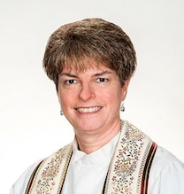
Pastor Karen will speak about and show pictures from her experiences with Hands On Hartford. She will help us focus on ways we might expand our SCC local and regional support to include Hands On Hartford and the models of “community help” for those neediest in our state and beyond. Check out Hands On Hartford http://www.handsonhartford.org

There will be time for:
- Presentation and questions
- Fellowship and networking
- Discussion and sharing
- Delicious light lunch of sandwiches, salad, dessert and beverages

All persons of any age and gender are welcome.
Join us and invite your friends and family.

Help us plan for the event by signing up on WF bulletin board or calling 860 429-9382 by Tuesday, March 7.

