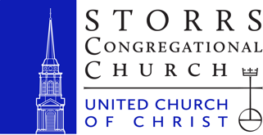
Attachment A

Governing Board
Consent Agenda

May 9, 2017

Consent Agenda for May 9, 2017

Be it moved and approved by consent:

Administrative:

- That the minutes of the March 21, 2017 meeting of the SCC Governing Board are approved as submitted.

2) That reports of Ministers, Officers, and Lead Ministry Coordinators are received:
  - April 2017 Balance Sheet
  - April 2017 Budget Report
  - Building and Grounds Report
  - Just Peace Team Meeting Minutes - April 25, 2017
  - Staff Report - Matt Emery
  - Treasurer’s Report to the Governing Board for April 2017 (May 4, 2017)
  - University Student Ministry report

3) That the Governing Board rescind its action of April 11 2017 appointing the Whitney Trust Fund Committee.

4) That Charlene Knapp, Eileen Metzgar, and Lawrence Mickel are appointed to serve as the trustees of the Whitney Trust Fund through January 2018.

